A.KPI’s

**1. Total Revenue:**

SELECT SUM(total_price)as Total_Revanue FROM pizza_sales

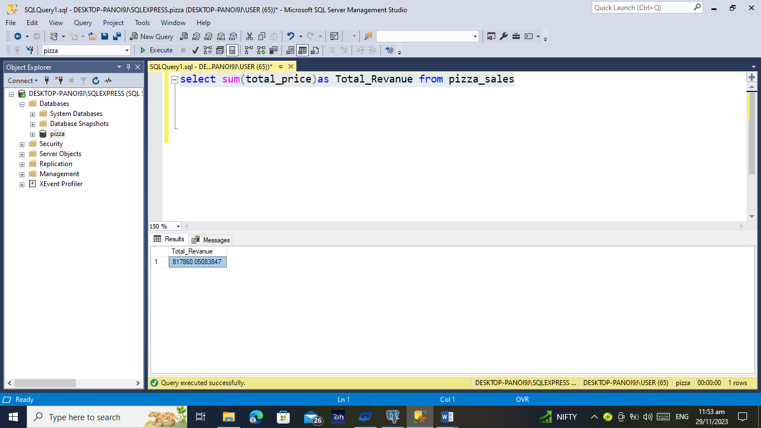

**2. Average Order Value:**

SELECT (SUM(total_price)/COUNT(order_id)) AS Avg_Order_Value FROM pizza_sales

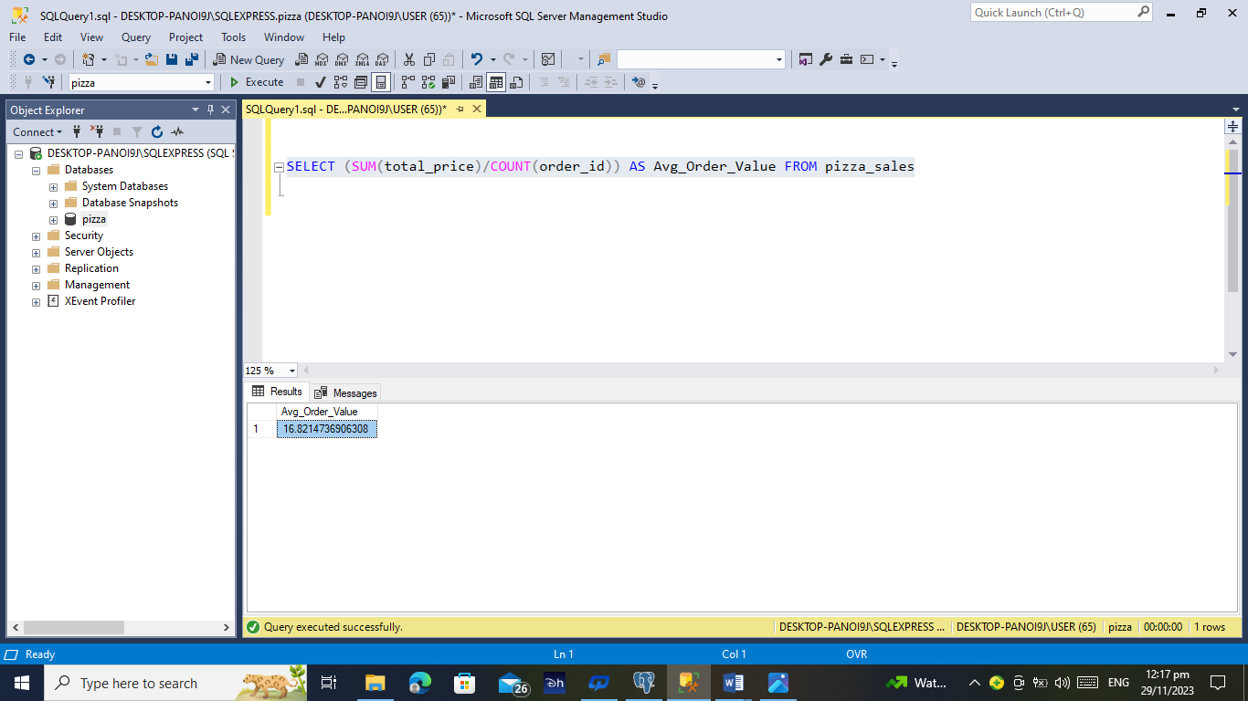

**3. Total Pizzas Sold**

SELECT SUM(quantity) AS Total_Pizza_Sold FROM pizza_sales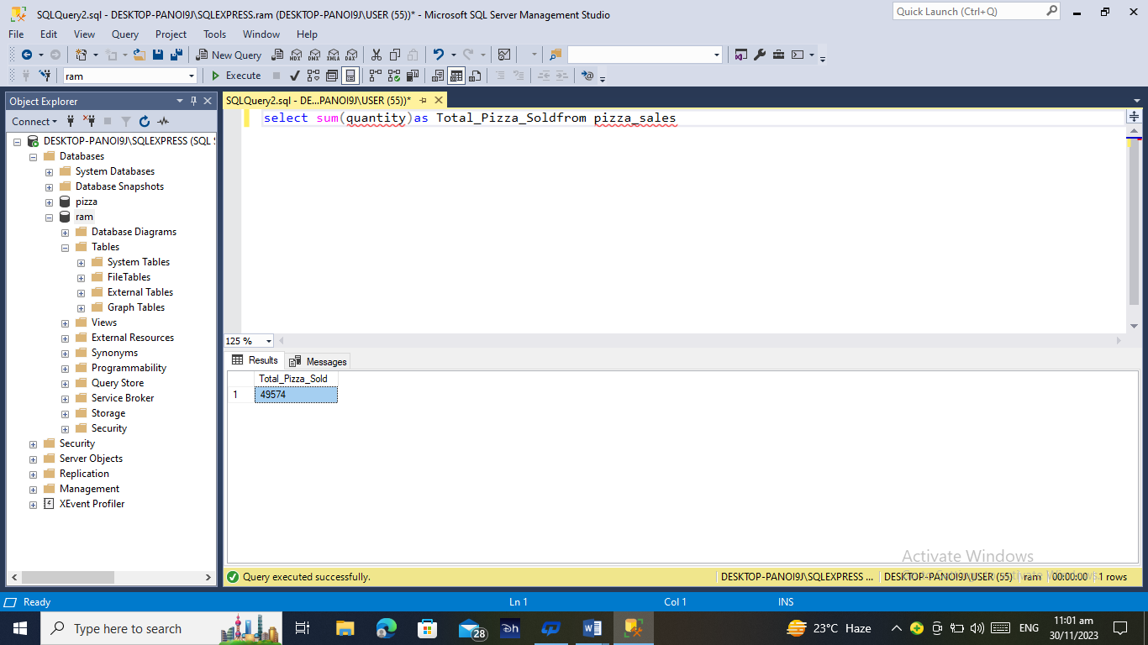

**4. Total Orders**

SELECT COUNT(DISTINCT(order_id)) AS Total_Oders FROM pizza_sales

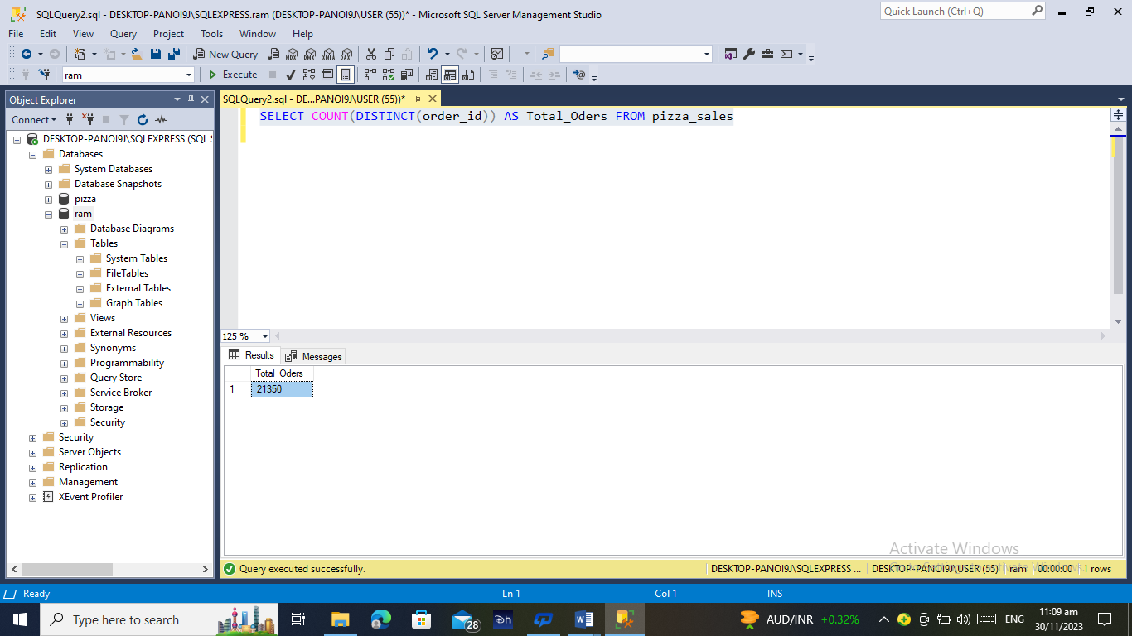

**5. Average Pizzas Per Order**

SELECT (SUM(quantity)/COUNT(DISTINCT(order_id))) AS Avg_Pizza_Per

_Order FROM pizza_sales

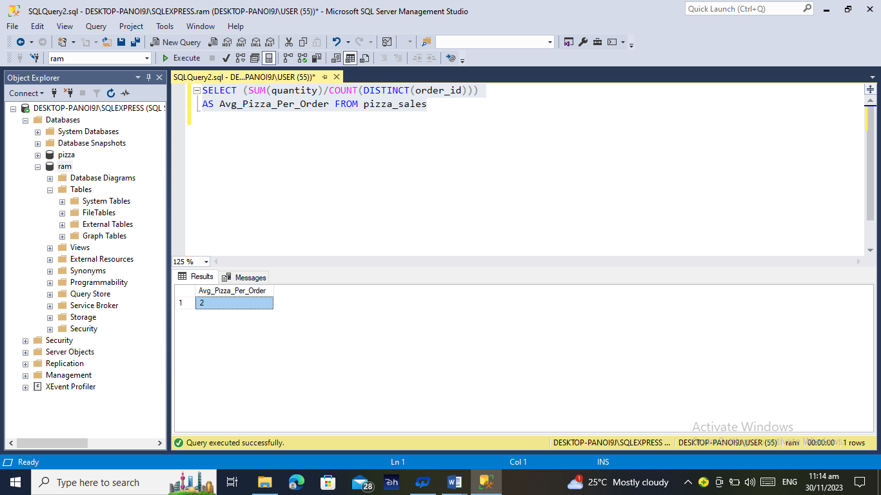

**B. Daily Trend for Total Orders**

SELECT DATENAME(DW, order_date) as order_day,Count(DISTINCT(ORDER_ID)) AS total_orders

FROM pizza_sales

GROUP BY DATENAME(DW, order_date)

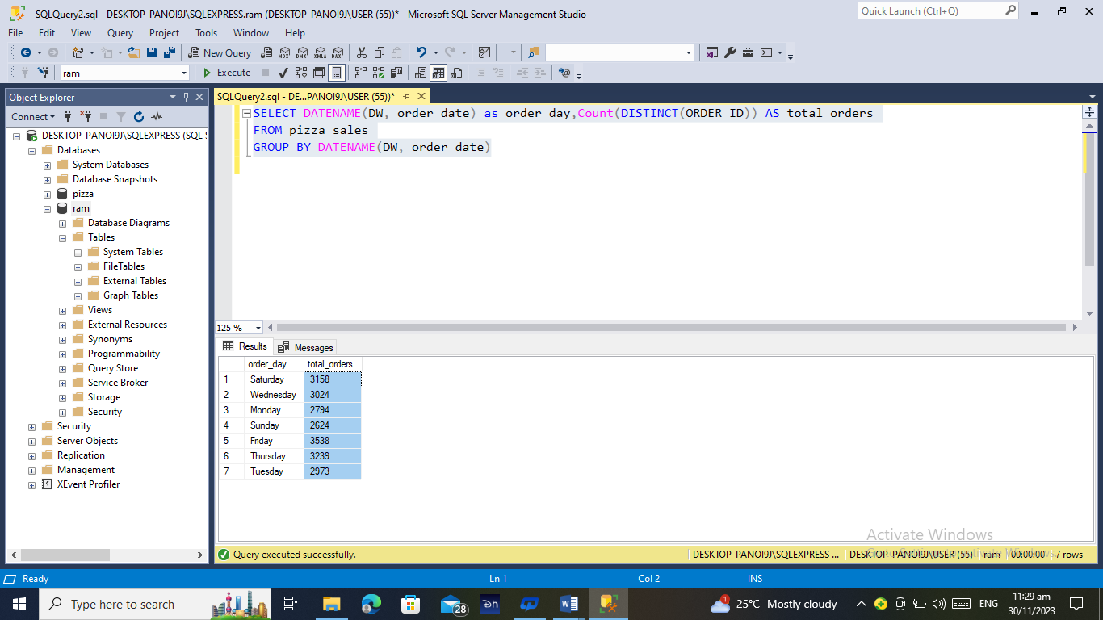

**C. Monthly Trend for Orders**

SELECT DATENAME(MONTH, order_date) as Month_Name,Count(DISTINCT(ORDER_ID)) AS total_orders

FROM pizza_sales

GROUP BY DATENAME(MONTH, order_date)

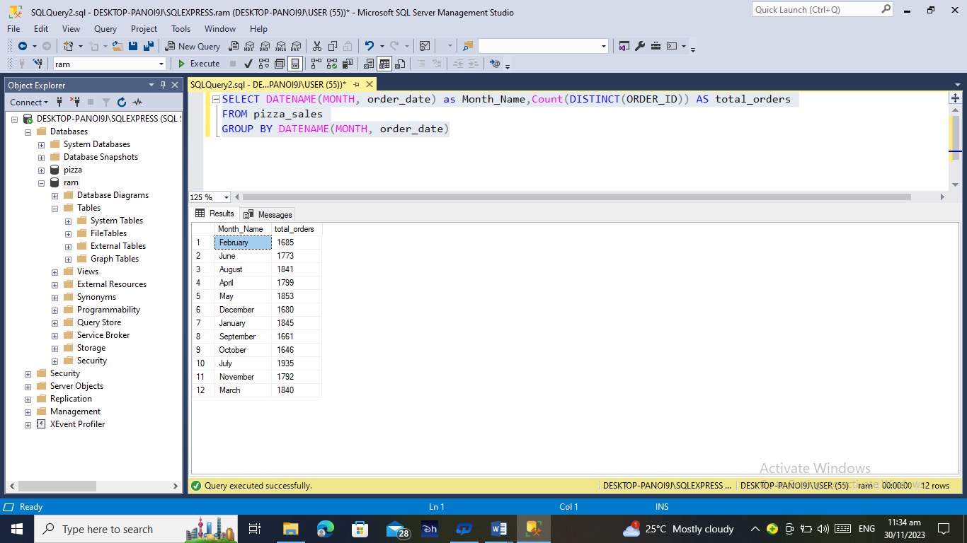

**D. % of Sales by Pizza Category**

SELECT pizza_category,(CAST(SUM(total_price)AS DECIMAL(10,2))) AS Total_Sales,CAST(SUM(total_price)*100 /

(SELECT SUM(total_price) From pizza_sales)AS DECIMAL(10,2)) AS PCT

FROM pizza_sales

GROUP BY pizza_category

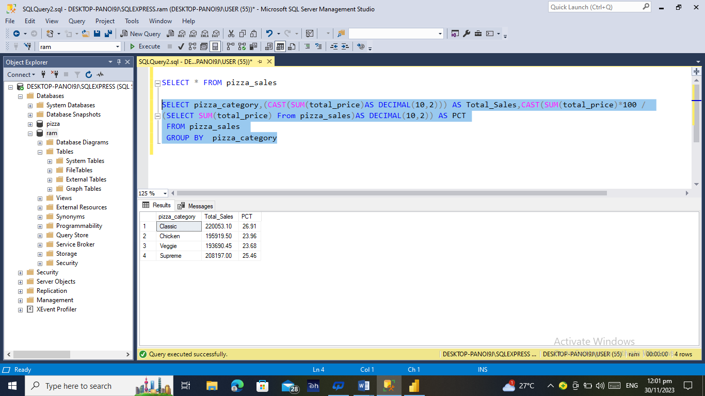

**E. % of Sales by Pizza Size**

SELECT pizza_size,(CAST(SUM(total_price)AS DECIMAL(10,2))) AS Total_Sales,CAST(SUM(total_price)*100 /

(SELECT SUM(total_price) From pizza_sales)AS DECIMAL(10,2)) AS PCT

FROM pizza_sales

GROUP BY pizza_size

ORDER BY PCT DESC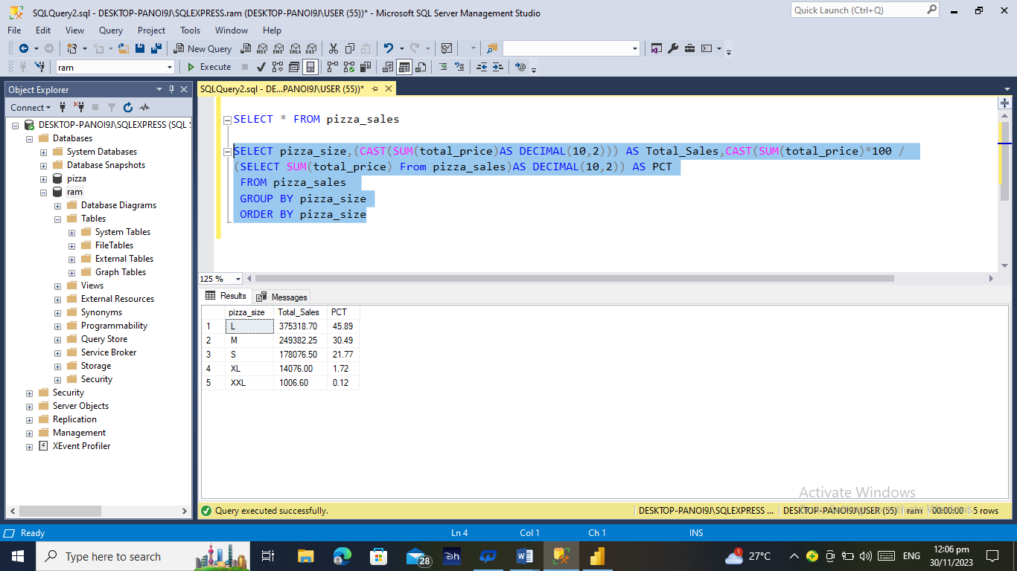

**F. Total Pizzas Sold by Pizza Category**

SELECT pizza_category, SUM(quantity) AS Total_Quantity_Sold

FROM pizza_sales

GROUP BY pizza_category

ORDER BY Total_Quantity_Sold DESC

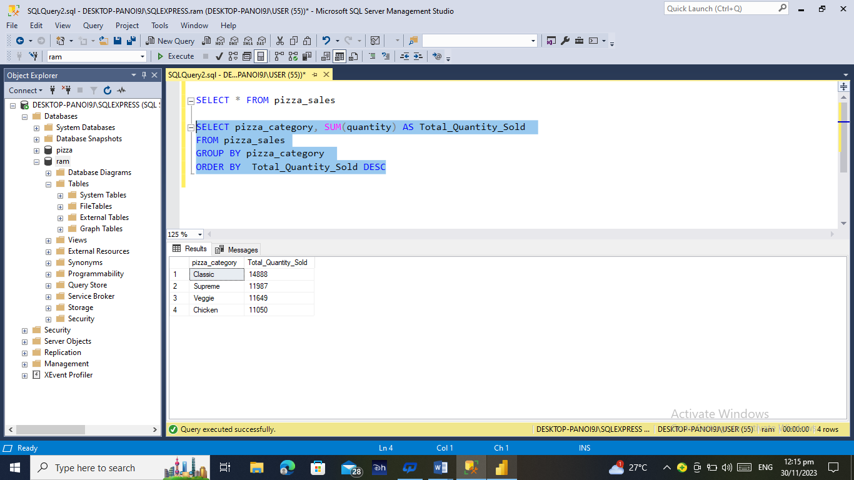

**G. Top 5 Pizzas by Revenue**

SELECT TOP 5 pizza_name, SUM(total_price) AS Total_Revanue

FROM pizza_sales

GROUP BY pizza_name

ORDER BY Total_Revanue DESC

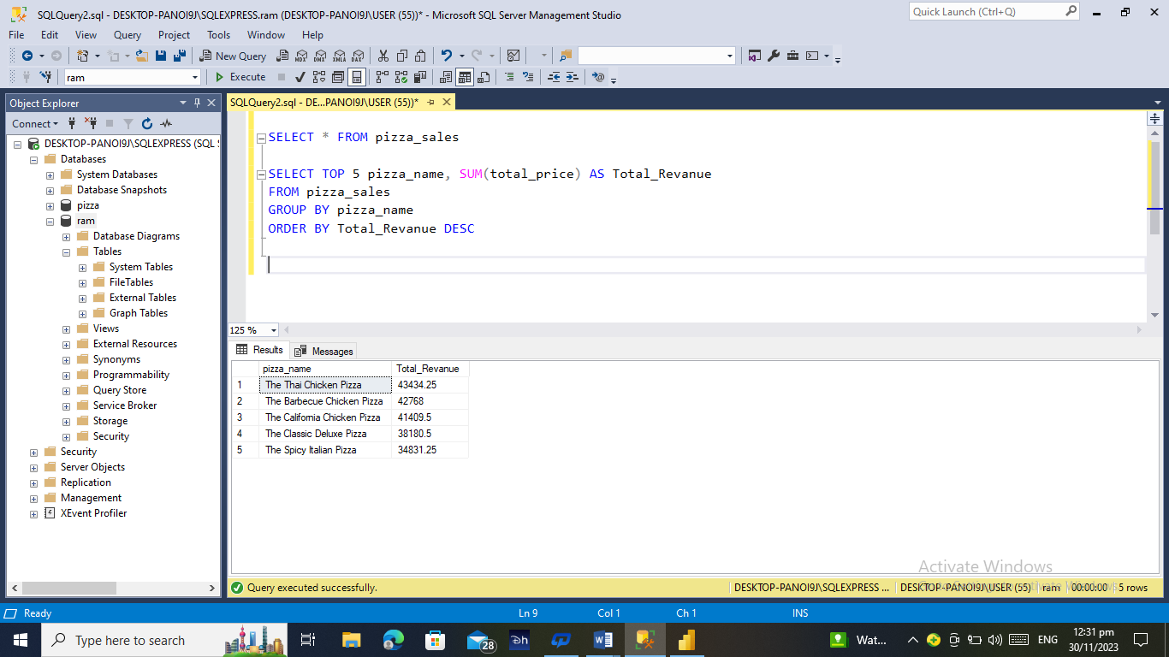

**H. Bottom 5 Pizzas by Revenue**

SELECT TOP 5 pizza_name, SUM(total_price) AS Total_Revanue

FROM pizza_sales

GROUP BY pizza_name

ORDER BY Total_Revanue ASC

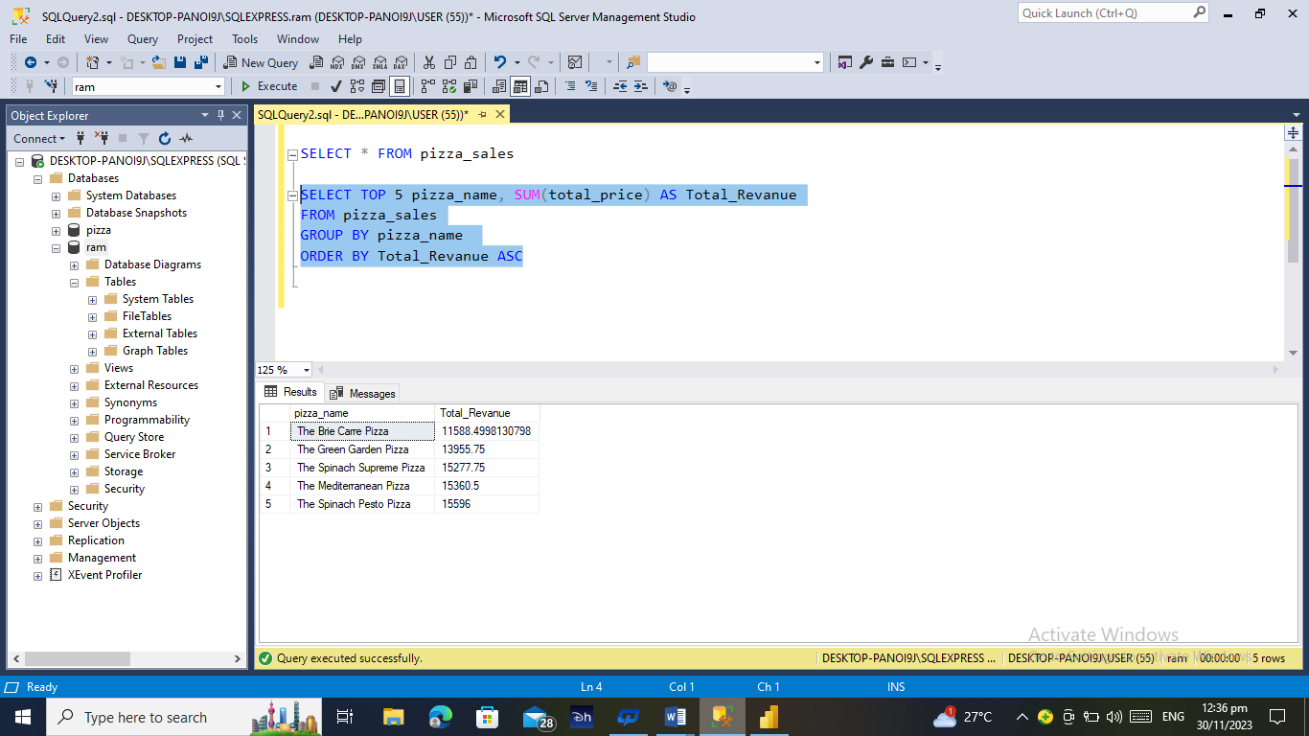

**I. Top 5 Pizzas by Quantity**

SELECT TOP 5 pizza_name, SUM(quantity) AS Total_Quantity

FROM pizza_sales

GROUP BY pizza_name

ORDER BY Total_Quantity DESC

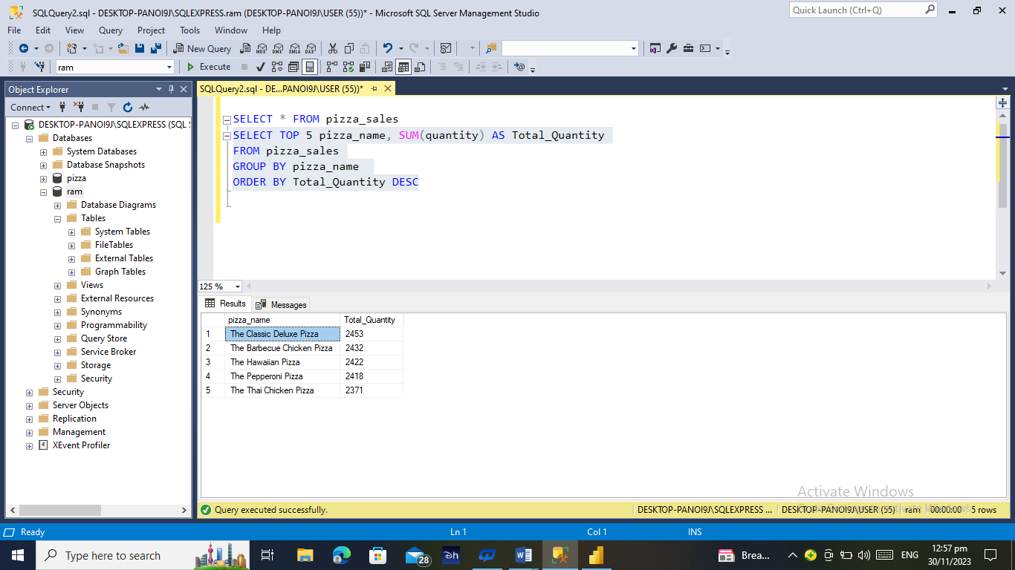

**J. Bottom 5 Pizzas by Quantity**

SELECT TOP 5 pizza_name, SUM(quantity) AS Total_Quantity

FROM pizza_sales

GROUP BY pizza_name

ORDER BY Total_Quantity ASC

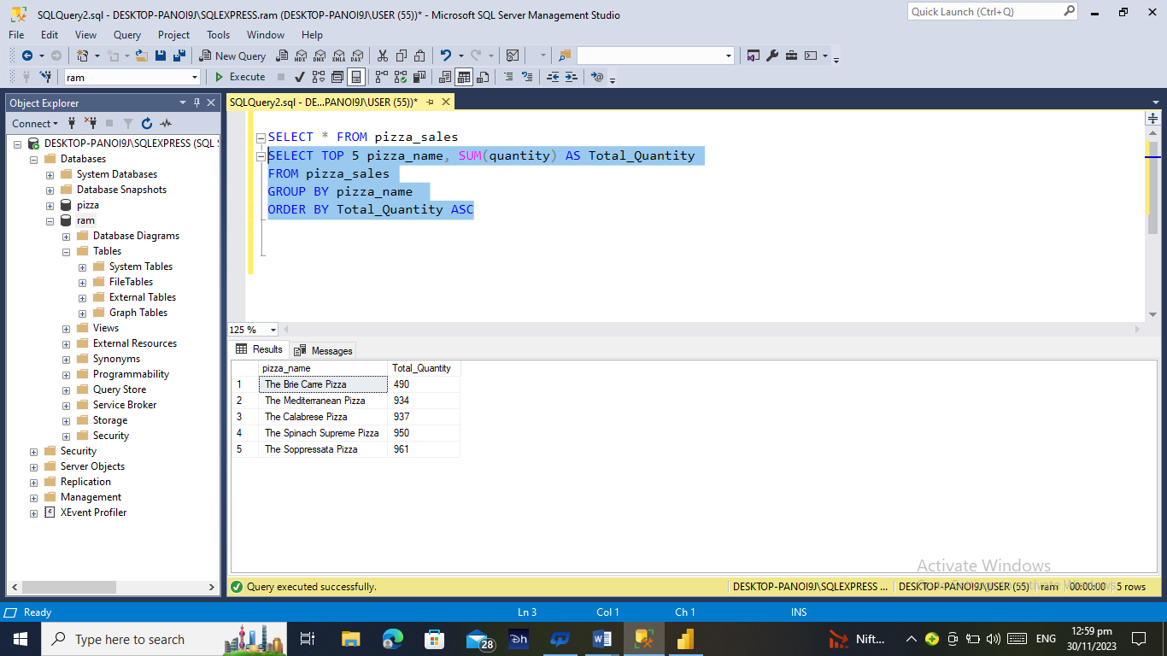

**K. Top 5 Pizzas by Total Orders**

SELECT TOP 5 pizza_name, COUNT(DISTINCT(order_id)) AS Total_Orders

FROM pizza_sales

GROUP BY pizza_name

ORDER BY Total_Orders DESC

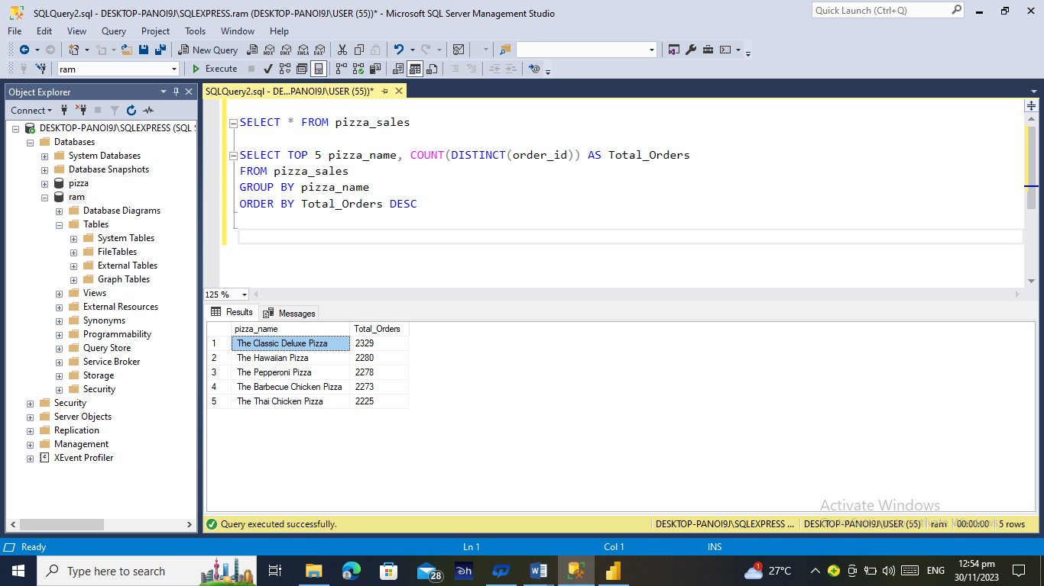

**L. Borrom 5 Pizzas by Total Orders**

SELECT TOP 5 pizza_name, COUNT(DISTINCT(order_id)) AS Total_Orders

FROM pizza_sales

GROUP BY pizza_name

ORDER BY Total_Orders ASC

